TOPIC – “ STUDY ON RURAL BANKING SCHEMES IN INDIA”
Submitted In Partial Fulfillment Of The Requirement Of The Award Of
BACHELOR OF COMMERCE
(BATCH : 2024-2025)


GUIDED BY: SUBMITTED BY:
DR. SUMAN PANDEY MEENAL PATEL

DEPARTMENT OF COMMERCE
SHRI SHANKARACHARYA PROFESSIONAL UNIVERSITY,
BHILAI, DURG, CHHATTISGARH

CERTIFICATE OF PROJECT GUIDE

This is to certify that the project work entitled “ TOPIC- “ STUDY ON RURAL BANKING SCHEMES IN INDIA”
Submitted to the “DEPARTMENT OF COMMERCE” by MEENAL PATEL roll no 2223030025 in partial fulfillment for the requirement relating to nature & standard of the award of degree of “ Bachelor of commerce” Degree by “SHRI SHANKARACHARYA PROFESSIONAL UNIVERSITY, BHILAI” for the academic year 2024-2025
This project work has been carried out under my guidance

GUIDED:
DR. SUMAN PANDEY
(ASSISTANT PROFESSOR OF COMMERCE)

CERTIFICATE OF APPROVAL

This is to certify that this project entitled “ STUDY ON RURAL BANKING SCHEMES IN INDIA” is carried out by “ MEENAL PATEL” , a student of B.COM VI SEMESTER at “DEPARTMENT OF COMMERCE” is here by approval as a credible work in the discipline of commerce for the award of degree of Bachelor of commerce during the year 2024-2025 from SHRI SHANKARACHARYA PROFESSIONAL UNIVERSITY,BHILAI

DR. SANJU SINGH
(HOD)

.
DECLARATION

This is to declare that the report entitled “ STUDY ON RURAL BANKING SCHEMES IN INDIA” is based on my own work carried out during the course of my study under the supervision of “ DR. SUMAN PANDEY”
I Further declare that the work reported in the project has not been submitted & will not be submitted, either in part or in full award of any other degree or diploma in this institute or any other institute or university

PLACE: BHILAI NAME: MEENAL PATEL
DATE: ROLL NO: 2223030025

CONTENTS

CHAPTERS | CONTENTS | PAGE  NO
CHAPTER 1 | INTRODUCTION
 | INTRODUCTION OF THE TOPIC
 | ORGANIZATIONAL STRUCTURE
 | LEGAL EXISTENCE AND PROTECTION
 | LIST OF REGIONAL RURAL BANKS
 | GOVERNMENT SCHEMES
CHAPTER 2 | LITERATURE REVIEW
CHAPTER 3 | RESEARCH STUDY
 | NEEDS OF THE STUDY
 | OBJECTIVES OF THE STUDY
 | HYPOTHESIS OF THE STUDY
CHAPTER 4 | RESEARCH METHODOLOGY
CHAPTER 5 | DATA ANALYSIS AND INTERPRETATION
CHAPTER 6 | CONCLUSION AND SUGGESTION
 | REFERENCES

INTRODUCTION



INTRODUCTION
Rural banking in India started since the establishment of banking sector in India and banking sector in India was set up on April,1935.In those days,rural banks basically focused upon the agriculture sector of India because a great percentage of Indian population is engaged in agricultural activities.Today, commercial banks and Regional rural banks in India are touching every corner of the country are extending a helping hand in the growth process of the rural sector in the country. To give this sector a stronghold on finance and to enable economic independence, rural banks have special offerings that extend credit facilities to small farmers, agricultural labors and cottage industry entrepreneurs.
Rural banking is the process of conducting banking transactions out in the country where bank branches are too far away to be of use. Rural banking is popular for very small towns and farmers who live far away from areas of larger population and cannot make the drive to these locations whenever they need to use banking services. Typically, an agent of the bank will visit these rural locations and offer to make transactions in an official capacity. To give this sector a stronghold on finance and to enable economic independence, rural banks have special offerings that extend credit facilities to small farmers, agricultural labors and cottage industry entrepreneurs.
Rural banking is the process of conducting banking transactions out in the country where bank branches are too far away to be of use. Rural banking is popular for very small towns and farmers who live far away from areas of larger population and cannot make the drive to these locations whenever they need to use banking services. Typically, an agent of the bank will visit these rural locations and offer to make transactions in an official capacity.

REGIONAL RURAL BANK

Regional Rural Banks (RRBs) are Indian Scheduled Commercial Banks (Government Banks) operating at regional level in different States of India. They have been created with a view of serving primarily the rural areas of India with basic banking and financial services. However, RRBs may have branches set up for urban operations and their area of operation may include urban areas too.

(RBI Governor, Shri Sanjay Malhotra)

“Simplicity and reliability in the financial inclusion in India, though not a cure, but can be a way of liberating the poor from dependence on indifferently delivered public services and from venal politicians. In order to draw in the poor, the products should address their needs – a safe place to save, a reliable way to send and receive money, and a quick way to borrow in times of need and to escape the clutches of Money Lenders” The area of operation of RRBs is limited to the area as notified by Government of India covering one or more districts in the State. RRBs also perform a variety of different functions. RRBs perform various functions in following heads:

• Providing banking facilities to rural and semi-urban areas.
• Carrying out government operations like disbursement of wages of MGNREGA workers, distribution of pensions etc.
• Providing Para-Banking facilities like locker facilities, debit and credit cards, mobile banking, internet banking, UPI etc.
• Small financial banks

Regional Rural Banks were established under the provisions of an Ordinance History passed on 26 September 1975 and the RRB Act 1976 to provide sufficient banking and credit facility for agriculture and other rural sectors. As a result, Five Regional Rural Banks were set up on 2 October 1975, Gandhi Jayanti. These were set up on the recommendations of The narshimham committee Working Group during the tenure of Indira Gandhi's Government with a view to include rural areas into economic mainstream since that time about 70% of the Indian Population was of Rural Orientation. The development process of RRBs started on 2 October G.S.College of Commerce and Economics,Nagpur 2021-22 Grishmi Karande BBA 3rd Year 1975,Gandhi Jayanti with the forming of the first RRB, the Prathama Bank,Head Office at Moradabad (U.P.) with authorized capital of Rs 5 crore at its starting. Prathama bank was sponsored by syndicate bank as on 2 October, 1975 Out of the remaining four RRBs in the country one was set up at Malda in West Bengal under the name of Gour Gramin Bank, which was the first RRB in the Eastern Region of India. The Regional Rural Banks were owned by the Central Government, the State Government and the Sponsor Bank (Any commercial bank can sponsor the regional rural banks) who held shares in the ratios as follows Central Government – 50%, State Government – 15% and Sponsor Banks –

REGIONAL RURAL BANKS(RRBs)

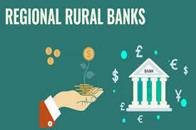

Type: Public
Industry: Banking, financial services
Founded: 2 October 1975 Gandhi Jayanti
Headquarters: India Number of locations: 21398(as on 2017)
Products: Retail banking, corporate banking, investment mortgage loans,
wealth management, debit card, UPI, internet banking, mobile banking,
finance
Owner: Government of India(50%), Sponsor Banks(35%),State Governments(15%)

Organizational Structure
The organizational structure for RRB's varies from branch to branch and depends upon the nature and size of business done by the branch. The Head Office of an RRB normally had three to nine departments. The following is the decision making hierarchy of officials in a Regional Rural Bank.

- Board of Directors
- Chairman & Managing Director
- General Manager
- Assistant General Manager
- Regional Manager/Chief Manager
- Senior Manager
- Manager
- Officer
- Office Assistant
- Office Attendant

Legal existence and protection

RRB are recognized by the law and they have legal significance. The Regional Rural Banks Act, 1976 Act No. 21 of 1976 [9 February 1976.] "For the incorporation, regulation and winding up of Regional Rural Banks with a view to developing the rural economy by providing, for the purpose of development of agriculture, trade, commerce, industry and other productive activities in the rural areas, credit and other facilities, particularly to the small and marginal farmers, agricultural laborers, artisans and small entrepreneurs, and for matters connected therewith and incidental thereto”.

List of Regional Rural banks
Presently there are 45 RRBs in India. On 1April 2020 the number of banks will be Reduce from 45 to 36

Andhra Pradesh
• Andhra Pragathi Grameena Bank[4]
• Chaitanya Godavari Grameena Bank
• Saptagiri Grameena Bank

Arunachal Pradesh
• Arunachal Pradesh Rural Bank

Assam
• Assam Gramin Vikash Bank

Bihar
• Dakshin Bihar Gramin Bank
• Uttar Bihar Gramin Bank

Chhattisgarh
• Chhattisgarh Rajya Gramin Bank

Gujarat
• Baroda Gujarat Gramin Bank
• Saurashtra Gramin Ban

Haryana
• Sarva Haryana Gramin Bank

Himachal Pradesh
• Himachal Pradesh Gramin Bank

Jammu and Kashmir
• J&K Grameen Bank
• Ellaquai Dehati Bank

Jharkhand
• Jharkhand Rajya Gramin Bank

Karnataka
• Karnataka Gramin Bank
• Karnataka Vikas Grameena Bank

Kerala
• Kerala Gramin Bank

Madhya Pradesh
• Madhyanchal Gramin Bank
• Madhya Pradesh Gramin Bank

Maharashtra
• Maharashtra Gramin Bank
• Vidharbha Konkan Gramin Bank
• Wainganga Krishna Gramin Bank

Manipur
• Manipur Rural Bank

Meghalaya
• Meghalaya Rural Bank

Mizoram
• Mizoram Rural Bank

Nagaland
• Nagaland Rural Bank

Odisha
• Odisha Gramya Bank
• Utkal Grameen Bank

Puducherry
• Puduvai Bharathiar Grama Bank

Punjab
• Punjab Gramin Bank

Rajasthan
• Baroda Rajasthan Kshetriya Gramin Bank
• Rajasthan Marudhara Gramin Bank

Tamil Nadu
• Tamil Nadu Grama Bank

Telangana
• Telangana Grameena Bank
• Andhra Pradesh Grameena Vikas Bank

Tripura
• Tripura Gramin Bank

Uttar Pradesh
• Aryavart Bank
• Prathama UP Gramin Bank
• Baroda UP Bank
• Purvanchal Bank
• Baroda UP Gramin Bank
• Kashi Gomti Samyut Gramin Bank

Uttarakhand
• Uttarakhand Gramin Bank

West Bengal
• Bangiya Gramin Vikash Bank
• Paschim Banga Gramin Bank-Sponsor Bank-UCO
• Uttarbanga Kshetriya Gramin Bank

Our focus is squarely on structural change. The reason for this is that there are many evidences which suggest that diversification out of agriculture is associated with increase in productivity and reduction in poverty. In particular, we may infer little about which policies might be effective in expanding the productive opportunities of households. A recent, mainly theoretical, study examines the determinants of diversification. This study points at credit market imperfections as an important reason for why individuals and economies get stuck in low productivity traps. The argument is that imperfect credit markets lead to the credit rationing of the poor. This, in turn, constrains their occupational and production choices. Credit rationing may thus act as a barrier to diversification and underlie poverty traps and persistent inequality. A suggested policy implication is that policies which provide the poor with access to credit may aid modernization and reduce poverty.

Historically, there have been four major problems with respect to the supply of credit to the Indian countryside.
• First, supply of formal sector credit to the countryside on the whole has been inadequate.
• Secondly, the rural credit markets in India have been very imperfect and fragmented.
• Thirdly, as the foregoing study suggests, the distribution of formal sector credit has been unequal, particularly with special reference to the region and class, caste and gender in countryside. Formal sector credit needs to reach backward areas, lowincome households, people of the oppressed castes and tribes, and women.
• Fourthly, the major source of credit to rural households, particularly low - income working households, have been the informal sector. Informal sector loans typically are advanced at very high rates of interest. Further, certain terms and conditions attached to these loans have given rise to an elaborate structure of coercion – economic and extra-economic – in the countryside.

After 1947, RBI sought to expand rural access to formal credit via the cooperative movement. However, by the mid-1960s it became apparent that increasing the quantum of finance of credit cooperatives by the RBI could not address the central problem. Still the bulk of rural India remains without a source of formal credit. After nationalization in 1969, the Reserve bank of India focused on Rural Banking and took control of the placement of banks as a means of advancing social objectives. During this period more than 50,000 new branches were built primarily in unbanked, rural locations. This represented a seven fold increase in the proportion of rural locations which were banked. Rural banking institutions are playing a very important role for all-round development of a rural area of the country. In order to support the rural banking sector in recent years, Regional Rural Banks have been set up all over the country with the objective of meeting the credit needs of the most under privileged sections of the society. These Regional Rural Banks (RRBs) have been receiving a high degree of importance and attention in the rural credit system. Considering the gross absence of banking facilities in the rural areas of the country, the Reserve Bank of India in consultation with the Central Government, State Government and some major nationalized sponsored banks had set up some Regional Rural Banks in the late 1970s with a view to elevate the economic status of the rural poor as well as to inculcate a habit of saving among the rural masses. The Rural Banking effects poverty in rural location. Poverty is central issue regarding branch expansion. The increase in branches built in unbanked locations reduces aggregate poverty whereas expanding branches in banked locations does not. There is no reason to think that building bank branches in unbanked rural locations would affect production and distribution relation in the urban sector. This paper would discuss the various schemes introduced by Government for rural development. Our focus, in particular, would be on whether policy driven branch expansion into unbanked locations helps to fulfill the financial needs of rural people or not.

RRBs though operate with a rural focus are primarily scheduled commercial banks with a commercial orientation. Beginning with the seminal contribution of Haslem (1968), the literature probing into factors influencing performance of banks recognises two broad sets of factors, i.e., internal factors and factors external to the bank. TheThe internal determinants originate from the balance sheets and/or profit and loss accounts of the bank concerned and are often termed as micro or bank-specific determinants of profitability. The external determinants are systemic forces that reflect the economic environment which conditions the operation and performance of financial institutions. A number of explanatory variables have been suggested in the literature for both the internal and external determinants. The typical internal determinants employed are variables, such as, size and capital [Akhavein et al. (1997), Demirguc-Kunt and Maksimovic (1998) Short (1979) Haslem (1968), Short (1979), Bourke (1989), Molyneux and Thornton (1992) Bikker and Hu (2002) and Goddard et al. (2004)]. Given the nature of banking business, the need for risk management is of crucial importance for a bank’s financial health. Risk management is a reflection of the quality of the assets with a bank and availability of liquidity with it. During periods of uncertainty and economic slow down, banks may prefer a more diversified portfolio to avoid adverse selection and may also raise their liquid holdings in order to reduce risk. In this context, both credit and liquidity risk assume importance. The literature provides mixed evidence on the impact of liquidity on profitability. While Molyneux and Thornton (1992) found a negative and significant relationship between the level of liquidity and profitability, Bourke (1989) in contrast, reports an opposite result. One possible reason for the conflicting findings may be the different elasticity of demand for loans in the samples used in the studies (Guru, Staunton and Balashanmugam, 2004). Credit risk is found to have a negative impact on profitability (Miller and Noulas, 1997). This result may be explained by taking into account the fact that more the financial institutions are exposed to high-risk loans, the higher is the accumulation of unpaid loans implying that these loan losses have produced lower returns to many commercial banks (Athanasoglou, Brissimis and Delis, 2005). Some of the other internal determinants found in the literature are funds source management and funds use management (Haslam, 1968), capital and liquidity ratios, the credit-deposit ratio and loan loss expenses [Short (1979); Bell and Murphy (1969); Kwast and Rose (1982)]. Expense management, a correlate of efficient management is another very important determinant of bank’s profitability. There has been an extensive literature based on the idea that an expenses-related variable should be included in the cost part of a standard microeconomic profit function. In this context, Bourke (1989) andMolyneux and Thornton (1992) find that better-quality management and profitability go hand in hand. As far as the external determinants of bank profitability are concerned the literature distinguishes between control variables that describe the macroeconomic environment, such as inflation, interest rates and cyclical output, and variables that represent market characteristics. The latter refer to market concentration, industry size and ownership status. Among the external determinants which are empirically modeled are regulation [Jordan (1972); Edwards (1977); Tucillo (1973)], bank size and economies of scale [Benston, Hanweck and Humphrey (1982); Short (1979)], competition [Phillips (1964); Tschoegl (!982)], concentration [Rhoades (1977); Schuster (1984)], growth in market [Short (1979)], interest rates as a proxy for capital scarcity and government ownership (Short, 1979). The most frequently used macroeconomic control variables are the inflation rate, the long-term interest rate and/or the growth rate of money supply. Revell (1979) introduced the issue of the relationship between bank profitability and inflation. He notes that the effect of inflation on bank profitability depends on whether banks’ wages and other operating expenses increase at a faster pace than inflation. Perry (1992) in a similar vein contends that the extent to which inflation affects bank profitability depends on whether inflation expectations are fully anticipated. The influence arising from ownership status of a bank on its profitability is another much debated and frequently visited issue in the literature. The proposition that privately owned institutions are more profitable, however, has mixed empirical evidence in favour of it. For instance, while Short (1979) provides crosscountry evidence of a strong negative relationship between government ownership and bank profitability, Barth et al. (2004) claim that government ownership of banks is indeed negatively correlated with bank efficiency. Furthermore, Bourke (1989) and Molyneux and Thornton (1992) find ownership status is irrelevant in explaining profitability. While many of the above factors would be relevant, it would be instructive to scan the literature that has exclusively focussed on the RRBs.

GOVERNMENT SCHEME
The Concept of priority sector lending with all its new dimensions has come to be recognized as “Social Banking”. Under Social Banking emphasis is on mass lending and the credit policy is consciously reoriented to meet the increasing needs and aspirations of the poor and down trodden in order to raise their standard of living. Main objective here is to make sure that more credit flows towards agricultural, small transport operators, retail trade, cottage, village & tiny industries, small scale industries etc. Agriculture being the back bone of Indian economy, Government has sponsored many schemes in rural areas for upliftment and betterment of rural people under rural banking. As per all Government schemes finance is provided by government banks. These schemes are as follows:-

- Swaranjayanti Gram Swarozgar Yojana(SGRY)
- Prime Minister Rozgar Yojana(PMRY)
- Pradhan Mantri Jan Dhan Yojana(PMJDY)
- Bhamashah Yojana(BY)
- National Bank for Agriculture and Rural Development(NABARD)
- Kisan Credit Card(KCC)

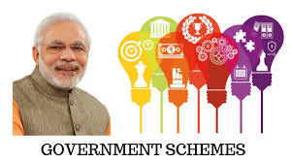

Swaranjayanti Gram Swarozgar Yojana (SGRY)

Swarnajayanti Gram Swarozgar Yojana is a scheme under which BPL families are formed as self-help groups and funded through bank loans and government funds. The main function of these groups is to help all such families cross the poverty line. Since the first of April 1999, the Indian government has actively been involved in helping the poorer citizens of the country in rural areas to create and maintain sustainable sources of income using their own skill, talents, and abilities.

The basic aim of the scheme is to provide a sustainable self-employment to the villages who are still unable to secure the financial position of individuals. It also ensures poor families who are living below poverty line to identify and encourage them to initiate a self-help group

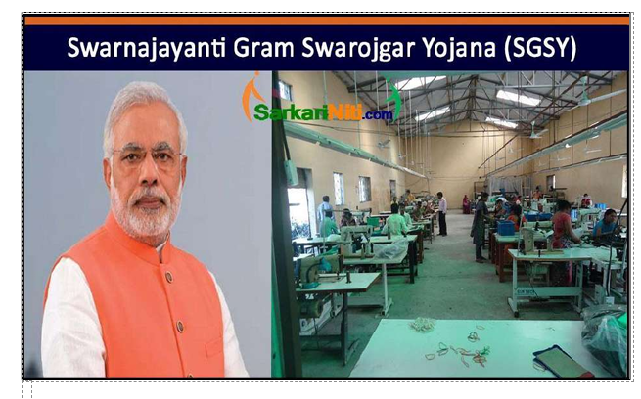

with the support provided by the government subsidy and credit provides by the banking sector. Scheme direct to increase the poor individuals or family to focus on finding the financial income sources based on their skills.

The government has managed this gargantuan task through the launch and operation of the Swarnajayanti Gram Swarozgar Yojana (SGSY) scheme, which targets economically weaker sections of the society and helps them organize and establish Self-Help Groups. These microenterprises are funded by the government, NGOs, individual philanthropists, CBOs, banks, and other sources of finance.

The scheme establishes Activity Groups, grouping together workers based on their individual skills and talents. Under the SGSY scheme, funding for these Self-Help Assemblies and activity Groups is routed through NGOs, banks, and monetary organizations with social outreach programs. Between 1999 and 2015, over 2.25 million Activity Groups and SelfHelp teams have been created, and operate with a total capital of over Rs.14,000 crores, providing a sustainable source of income to over 6.5 million people.

How it works
Under the scheme, poorer families that were below the Poverty Line were organized into Self-Help groups, which were funded through a mix of government funds and small loans from banks. The primary function of the Self-Help groups was to help these families cross the Poverty Line, and generate a sustainable source of profits through a joint effort. After the families were able to help themselves out of the scarcity line, the Self-Help groups were organized in such a way that every member of the group could contribute to the achievement of a common objective. Groups were organized on the basis of common skills, the skill level of the members, and the amount of time and work they could contribute.

Important Groups
1. Group Creation: This involves process like enquiring and judging skills, selecting individuals and assigning people to groups based on the skill level of each member.
2. Capital Creation: A rotating fund system is adopted for capital generation, and skills are allowed to develop through experience.
3. Implementation: Abilities and group skills are created and developed further as the process functions at the group’s chosen speed, limited usually only by level of skill.
Self-Help Groups are formed after a process of selection. The BPL (Below Poverty Line) Index / Inventory is acquired from the Gram Sabha and used by the organization to choose appropriate members based on its own criteria. The groups are then assimilated into blocks focussing on the group’s primary output capabilities, and allowed to work with funding from banks, individual philanthropists, Panchayati Raj organizations, and the like. Regular festivals and melas are organised by the government, in an effort to help the Self-Help Groups sell their output / goods to a larger audience and create a market in the process.
Self-Help Groups are formed after a process of selection. The BPL (Below Poverty Line) Index / Inventory is acquired from the Gram Sabha and used by the organization to choose appropriate members based on its own criteria. The groups are then assimilated into blocks focussing on the group’s primary output capabilities, and allowed to work with funding from banks, individual philanthropists, Panchayati Raj organizations, and the like. Regular festivals and melas are organised by the government, in an effort to help the Self-Help Groups sell their output / goods to a larger audience and create a market in the process.

Schemes Replaced
The scheme effectively replaces for the following other schemes:

• Integrated Rural Development Program (IRDP)
• Training of Rural Youth for Self-Employment (TRYSEM)
• Development of Women and Children in Rural Areas (DWCRA)
• Supply of Improved Toolkits to Rural Artisans (SITRA)
• Ganga Kalyan Yojana (GKY)
• Million Wells Scheme (MWS)

Objective
The scheme is established with the intent of bringing the assisted low-income families (also referred to as swarozgaris) above the poverty line by providing them with an appreciable sustained income over a period of time. This shall be fulfilled by organizing the rural poor into Self-Help Groups (SHGs) through the process of social mobilization, training, capacity building and provision of income generating assets.
The scheme envisages the development of activity clusters with an emphasis on key activities identified in the block, both for the group as well as for individual assistance. These activity clusters will be in geographic clusters of neighbouring villages within a reasonable radius.

Self-Help Groups
The Self-Help Groups (SHGs) will be organized by ‘Swarozgaris’ drawn from the BPL list approved by the Gram Sabha. The scheme facilitates the formation of Self-Help Groups (SHGs), who will be assisted on a loan-cum-subsidy basis for undertaking income-generating activities. The scheme regulations state that half of the groups formed at the block level should be exclusively women groups.

Coverage of the Scheme
The scheme caters to the rural communities such as those with land, landless labour, educated unemployed, rural artisans and the disabled. The assisted low-income families could be either individuals or groups and would be selected from Below Poverty Line (BPL) families by a three-member team comprising of a Block Development Officer (BDO), banker and sarpanch. The scheme specifically focuses on the vulnerable sections of the rural poor. The SC/ST would gain the bulk of assistance (50%), while a proportion of the remaining funds would be earmarked for women and the disabled.The scheme is aimed at the development of Swarozgaris through training courses that are designed in accordance with the activities selected and the requirements of each swarozgari.

Roadmap
The initiative focusses on establishing a large number of micro-enterprises in rural areas based on the potential of such areas (land-based or otherwise). Due consideration is accorded to different components such as capacity building of the poor, skill development training, credit, training, technology transfer, marketing and infrastructure.

The scheme entails the following processes:

• Group Creation – This stage covers the assessment of the skill level of the members
.• Capital Creation – This involves the use of a rotating fund system. Here, the members are facilitated to hone their skills through experience
.• Implementation – the final stage deals with the identification and nurturing of abilities and group skills. The implementation is processed according to the pace desired by the respective groups.

Sealing of Subsidies
The subsidy allocation for the scheme is as follows:

• A uniform subsidy of 30% of the total project cost is allowed under the scheme, subject to a ceiling of Rs. 7,500.
• A subsidy of 50% of the total project cost, subject to a ceiling of Rs. 10,000 is extended to SC/STs and disabled persons.
• A subsidy of 50% of the total project cost, subject to a ceiling of Rs. 1.25 lakh or per capita subsidy of Rs. 10,000 (whichever is less) is provided to Self-Help Groups (SHGs) and individual swarozgaris.
• No monetary limits on subsidy have been specified for irrigation projects.
• Subsidy under these provisions is back-ended. The banks are prohibited from charging interest on the subsidy portion of the loan amount.
• As already stated, special emphasis will be laid on vulnerable groups among the rural poor

Funding and Training
The maintenance, education, and funding for these groups comes from NGOs, philanthropists, CBOs, banks, organizations promoting self-aid, and District Land Development Agencies (DRDAs) that are owned by the government. Some of the institutions that offer funding mentioned above also offer training and education facilities to group members, and organize their own teams based on the training required for a particular Self-Help Group’s specific skill.
Salient features of the schemes:
- Identifying the eligible beneficiaries with involvement of Gram / Local authorities in a transparent manner.
2. Providing freedom to Branch Managers for satisfying themselves about the beneficiaries and activity proposed to be financed.
3. Lending to individuals or group (SHGs) and selecting beneficiaries from BPL families by a team of three members (Bankers, Development Officer, Sarpanch)
4. Provision for training (Basic orientation and skill development) in the scheme. The Basic orientation programme is mandatory. Skill development training has to necessarily be undergone by the Swarozgaries wherever needed as assessed by Technical Line Department and Financing Bank
5. Individuals or groups below poverty line whose income does not exceed 11,500/- sponsored by DRDA reserve quota for SC / ST – 50% , Women- 40% & Disabled 3%
6. Security norms for individual loans up to Rs. 50000/- and group loans till Rs. 3 lakhs are assets created out of bank loan which would be hypothecated to the bank as a primary security. For loans in excess of the above units, in addition to primary security collateral security in the form of third party guarantee, assignment of LIC policies, marketable securities or deeds of other property etc. might be obtained
7. Subsidy will be at 30% of project, subject to a maximum Rs. 7500/- . In respect of SC / ST it will be 50% of the project subject to maximum of Rs. 10000/- . For SHGs the subsidy will be 50% of the cost of the project, subject to a ceiling of Rs. 1.25 lakhs. There will be no monetary limit on subsidy for irrigation projects
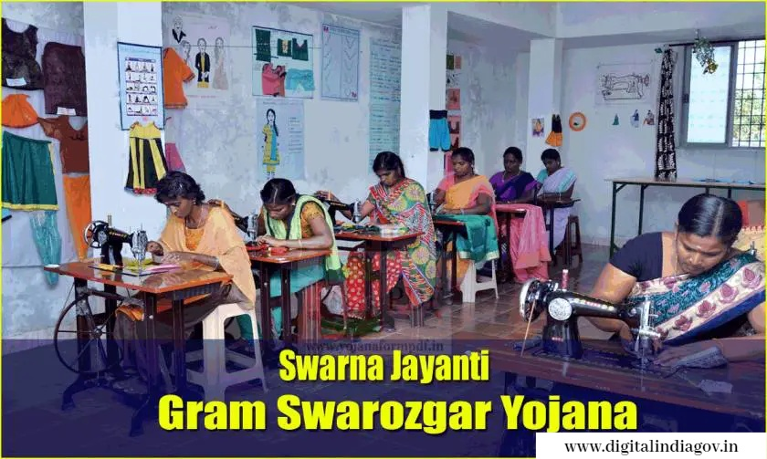

Prime Minister Rozgar Yojana (PMRY)

The unemployed youth in our country have tremendous potential. Given the right opportunity they can contribute towards economic development of the nation. The Prime Minister Rozgar Yojana (PMRY) implemented since 2nd October 1993, aims at providing sustained employment to educated unemployed youth.
PMRY (Prime Minister’s Rozgar Yojana) is initiated by Central Government of India to provide sustainable self-employment opportunities to ten lakh educated unemployed youth and women in India. Initiated this cause during the eighth plan period. The scheme offers financial assistance in starting one’s own enterprise in trade, manufacturing, and services sectors.
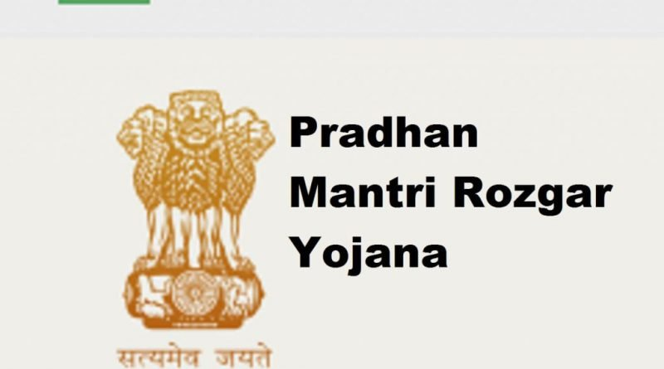
PMRY aims in setting up of 7 lakh micro enterprises through inducting service and business Venture over a period of 2 years 6 months. Small Scale Industries (SSI) uses its vision to utilize local resources, technologies for productive purposes and exploit the local market at micro level.

PMRY – Eligibility

Age: For all educated unemployed people between 18-35 years

Educational Qualification: 8th standard – Passed

Interest Rate: Normal interest rate shall be charged

Repayment Schedule: Between 3 to 7 years after an initial moratorium

Family Income: Income of beneficiary along with spouse nor the income
of parents shall exceeds Rs.40000/month

Residence: Permanent resident of the area for at least 3 years

Defaulter: Should not be a defaulter to any nationalized financial
Institution /bank/cooperative bank

Subsidy and Margin money: Subsidy will be limited to 15% of the project cost subject
to ceiling of Rs. 7,500 per borrower

Collateral: No collateral for project up to Rs.1 lakh

Reservation: Weaker sections (SCs/STs), including women

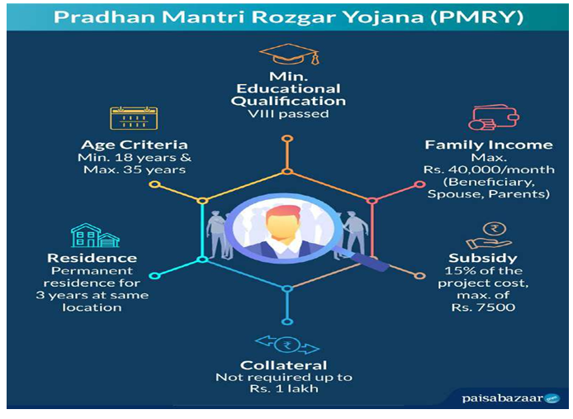

How to apply for PMRY Loan?
Step 1: Visit the official website of Prime Minister’s Rozgar Yojana.
Step 2: Download the application form and fill it with complete details.
Step 3: Submit the duly filled form to the respective bank those which come under PMRY scheme and then the concerned bank will get in touch with you

Feature | Description
Implementation | This scheme is implemented at the state level with the help of banks, Directories of Industries and District Industry Centres.
Collateral | Prime Minister Yojana offers the eligible candidate a loan of maximum Rs.1 lakh without any collateral.
Traning facility | Borrowers are also entitled to receive 15-20 days of training under this scheme. The training is mostly aimed at educating about the basics of setting up a business and making sound investments.
Subsidy | Prime Minister Rozgar Yojana Scheme also extends subsidy to qualified individuals. They can receive 16% of the project in question’s cost as a subsidy. However, the upper limit for the project cost is set at Rs.12500 per individual.
EMI | Beneficiaries have the option to receive a PMRY loan in the form of EMIs. They can also choose to repay the sanctioned loan in monthly instalments.

Copies of the following documents are required to apply for Pradhan Mantri Rozgar Yojana (PMRY):
• License
• EDP Training certificate
• Copy of the Proposed Project Profile
• Experience, qualification, and technical certificates
• Proof of Date of Birth (SSC certificate or TC from school where studied)
• Residence proof for 3 years, ration card or any other proof of residency
• Income certificate issued by MRO (Mandal Revenue Officer)
• Caste certificate issued by MRO, if applicable Driving

Pradhan Mantri Jan-Dhan Yojana (PMJDY)

Pradhan Mantri Jan Dhan Yojana (PMJDY), is financial inclusion program of Government of India which is applicable to 10 to 65 years age group that aims to expand and make affordable access to financial services such as bank accounts, remittances, credit, insurance and pensions. This financial inclusion campaign was launched by the Prime Minister of India Narendra Modi on 28 August 2014. He had announced this scheme on his first Independence Day speech on 15 August 2014.

Pradhan Mantri Jan Dhan Yojana(PMJDY)
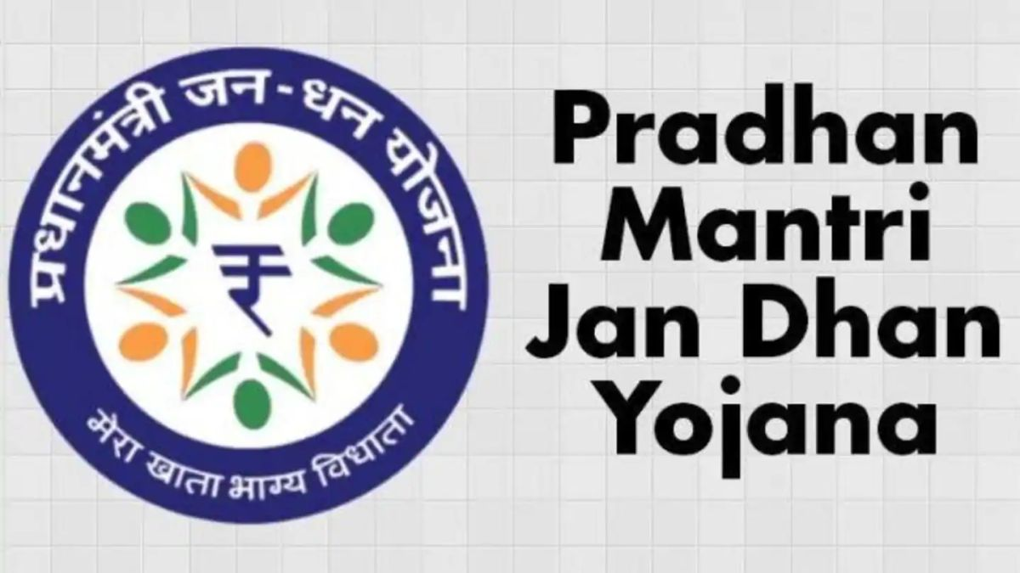
PM Modi launches the “Pradhan Mantri Jan Dhan Yojana”
Country: India
Prime Minister: PM Narendra Modi
Ministry: Finance
Key People: Arun Jaitley
Launched: 28 August 2014
Status: Active
Website: www.pmjdy.gov.in

Run by Department of Financial Services, Ministry of Finance, under this scheme 15 million bank accounts were opened on inauguration day. The Guinness Book of World Records Pradhan Mantri Jan Dhan Yojana ( PMJDY ) recognized this achievement, stating: "The most bank accounts opened in one week as a part of the financial inclusion campaign is 18,096,130 and was achieved by the Government of India from August 23 to 29, 2014". By 27 June 2018, over 318 million bank accounts were opened and over ₹792 billion (US$12 billion) were deposited under the scheme
Slogan of the Scheme is "Mera Khatha, Bhagya Vidhatha (meaning "My account brings me good fortune") The scheme was launched after the failure of previous such schemes including Swabhimaan. Swabhimaan was a campaign of the Government of India which aims to bring banking services to large rural areas. It was launched by Sonia Gandhi, the Chairperson of the United Progressive Alliance party in the presence of Shri Pranab Mukherjee, the Union Finance Minister and Namo Narain Meena, the Union Minister of State for Finance on February 10, 2011

Investments
Pradhan Mantri Jan-Dhan Yojana statistics as on 3 July 2019(All figures in millions)

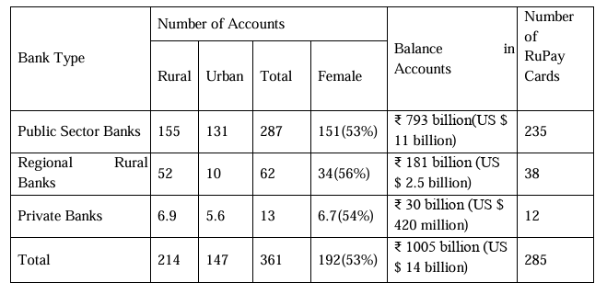
Performance
Due to the preparations done in the run-up, as mentioned above, on the inauguration day, 15 million bank accounts were opened. The Prime Minister said on this occasion- "Let us celebrate today as the day of financial freedom." By September 2014, 30.2 million accounts were opened Bank]] with 2.024 million accounts, Canara Bank 1.621 million accounts, Central Bank of India 1.598 million accounts and Bank of Baroda with 1.422 million accounts. On 20 January 2015, the scheme entered into Guinness book of world records setting new record for 'The most bank accounts opened in one week'. The balance in Jan Dhan accounts rose by more than ₹270 billion (US$3.8 billion) between 9 November 2016 and 23 November 2016. 1.9 million Householders have availed the overdraft facility of ₹2.56 billion (US$36 million) by May 2016. Uttar Pradesh and West Bengal have got 29% of the total deposits under the scheme, whereas Kerala and Goa became the first states in the country to provide one basic bank account to every household. The total number of account holders stood at 294.8 million, including 176.1 million account holders from rural and semi-urban branches. A total of 227 million RuPay cards have been issued by National Payments Corporation of India (NPCI) till August 2017. The amount of deposits rose to ₹656.97 billion (US$9.2 billion) by August 2017. According to an analysis of various studies, "Beyond enabling account ownership and the use of financial services, the PMJDY also facilitated financial inclusion for a variety of demographics. While the programme has made significant headway towards genuine financial inclusion, it is clear that improving policy communication, widening and deepening progress in low-income states, and ironing out the kinks in the bank-agent model will be crucial if these hard-fought gains are to prove sustainable." At least 300 million new families have got Jan Dhan accounts in which almost ₹650 billion (US$9.1 billion) have been deposited, Prime Minister Narendra Modi said on 28 August 2017, on the eve of third anniversary of the scheme aimed at financial inclusion. The scheme has been criticized by opposition as an effort to please voters.

PMJDY Information
Interest Rate | Based on the saving’s account interest rate offered by the bank
Minimum Balance | Zero balance account
Accidental  Insurance cover | Under Rupay Scheme, Rs.1 lakh.  Accounts opened after 28 August 2018,  Rs.2 lakh
Overdraft Facility | Provided

Benefits under PMJDY
1. One basic savings bank account is opened for unbanked person.
2. There is no requirement to maintain any minimum balance in PMJDY accounts.
3. Interest is earned on the deposit in PMJDY accounts.
4. Rupay Debit card is provided to PMJDY account holder.
5. Accident Insurance Cover of Rs.1 lakh (enhanced to Rs. 2 lakh to new PMJDY accounts opened after 28.8.2018) is available with RuPay card issued to the PMJDY account holders.
6. An overdraft (OD) facility up to Rs. 10,000 to eligible account holders is available.
7. PMJDY accounts are eligible for Direct Benefit Transfer (DBT), Pradhan Mantri Jeevan Jyoti Bima Yojana (PMJJBY), Pradhan Mantri Suraksha Bima Yojana (PMSBY), Atal Pension Yojana (APY), Micro Units Development & Refinance Agency Bank (MUDRA) scheme.

Criticism
The scheme has been criticized by opposition as an effort to please voters that has created unnecessary work-burden on the public-sector banks. It has been claimed that the poor deserve food more than bank accounts and financial security. Further, these accounts have not yet added considerable profits to PSU banks. According to the experts, offers like zero balance, free insurance and overdraft facility would result in duplication. Many individuals who already have bank accounts may have had accounts created for themselves, lured by the insurance covers and overdraft facilities. As per the scheme, a very few people are eligible to get the life insurance worth ₹30,000 (US$420) with a validity of just five years. The claimed overdraft facility has been completely left upon the banks. As per the government notice, only those people would get the overdraft facility whose transaction record has satisfactory operations in their account for some time. In addition, while the Indian Government was actively attempting to promote financial inclusion through this scheme, the Reserve Bank of India, permitted banks to charge customers for conducting ATM transactions beyond a certain number of times per month. This effectively prevented people from easily accessing their own savings and discouraged them from using formal banking channels.

Coverage
The survey was conducted between October and November 2015 in 42 districts of 17 states and one Union Territory. A total of 1,627 BM locations were physically visited to verify their presence and BMs were interviewed at locations where they were available. In addition, 4,859 PMJDY customers spread across these locations were also interviewed to obtain their feedback on different aspects of the scheme, especially with regard to service delivery, preferences, and availability of Aadhaar and RuPay cards.

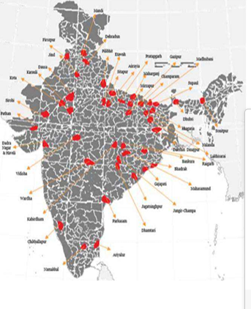

States and numbers of District covered

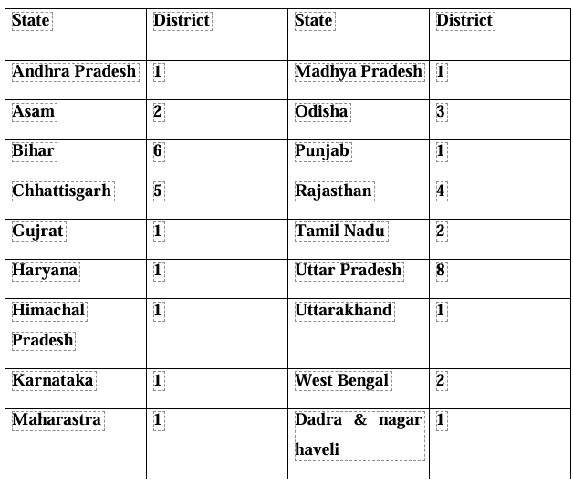

KISAN CREDIT CARD (KCC)
The Kisan Credit Card (KCC) is a government-initiated scheme designed to provide farmers with timely access to credit for their agricultural needs. Introduced in August 1998 by Indian public sector banks under the guidance of the National Bank for Agriculture and Rural Development (NABARD), the KCC aims to meet the comprehensive credit requirements of farmers, including activities related to crop production, post-harvest expenses, and allied sectors like fisheries and animal husbandry.

​ 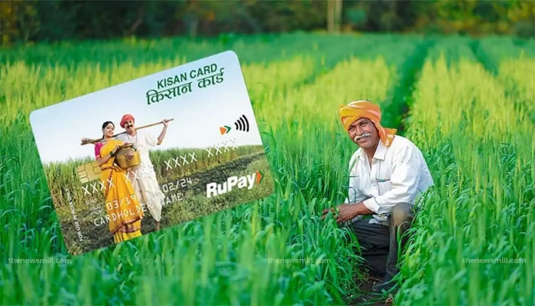

KEY FEATURES:

- Credit Limit: Farmers can avail of loans up to ₹5 lakh under the KCC scheme. The credit limit is determined based on factors such as landholding, cropping pattern, and financial needs. Notably, loans up to ₹1.6 lakh do not require collateral, promoting easier access to credit. ​
- Interest Rate: The interest rate on KCC loans is generally around 7% per annum. An additional benefit is the interest subvention provided by the government, which offers a 3% reduction for timely repayment, effectively reducing the interest rate to 4% for prompt payers. ​
- Repayment Period: The KCC offers flexible repayment options. Short-term loans typically have a repayment period aligned with the crop cycle, while term loans for investments in agricultural infrastructure can extend up to 5 years. ​
- Insurance Coverage: Cardholders receive personal accident insurance coverage of up to ₹50,000 for death and permanent disability, with the premium shared between the bank and the borrower in a 2:1 ratio. ​
- Digital Features: The KCC is equipped with a Personal Identification Number (PIN) and an International Identification Number (IIN), functioning as a magnetic stripe card. This allows farmers to withdraw funds from ATMs and access credit conveniently.

ELIGIBILITY CRITERIA:

- Age: Applicants must be between 18 and 75 years of age. For those above 60, having a co-applicant is mandatory. ​
- Occupancy: The scheme is open to individuals involved in crop production, including tenant farmers, oral lessees, and sharecroppers. It also extends to fishermen, dairy farmers, and individuals engaged in animal husbandry.

APPLICATION:

- Offline Application:
- Visit the nearest branch of any commercial bank ,regional rural bank ,or cooperative bank offering the KCC.
- Fill out the KCC application form, providing necessary details about landholding, cropping pattern, and other required information.
- Submit the completed form along with documents such as proof of identity, address proof, land ownership records, and photographs.
- The bank will process the application, and upon approval, the KCC will be issued.

- Online Application
- Many banks offer online application for the KCC. Visit the official website of your chosen bank.
- Navigate to the KCC section and fill out the online application form with accurate details.
- Upload necessary documents as specified by the bank.
- After submission, the bank will review your application , and upon approval, the KCC will be dispatched to your registered address.

OBJECTIVE:
This objective of the Kisan Credit Card (KCC) is to provide timely and easy access to credit for farmers and agricultural workers to meet their financial requirements for farming activities and related ventures.
The key goals include:

- Providing Financial Support to Farmers: The KCC aims to offer farmers quick access to working capital for crop production, purchasing inputs like seeds, fertilizers, pesticides, and paying for labour and irrigation costs. It also helps with post-harvest expenses and financing other agricultural activities.
- Enhancing Credit Availability: By offering low-interest loans without the need for collateral (for loans up to Rs. 1.6 lakh), the KCC helps to overcome the problem of limited access to formal credit channels, especially in rural areas.
- Improving Agricultural Prouctivity: The card enables farmers to invest in improved agricultural techniques, machinery, and infrastructure, thereby boosting productivity and efficiency in farming.
- Ensuring Timely Repayment Benefits: Farmers who repay their loans on time receive interest subsidies, reducing the cost of borrowing and promoting a disciplined approach to loan repayment.
- Financial Inclusion for Small and Marginal Farmers: The KCC is designed to cater to all types of farmers, including small, marginal, and tenant farmers, thus ensuring financial inclusion for a wide segment of the rural population.
- Supporting Allied Agricultural Activities: The card also covers credit needs for activities related to animal husbandry, fisheries, and other rural enterprise , expanding its scope beyond crop production.
- Ease of Use and Accessibility: With features like ATM access, mobile banking, and digital integration, the KCC provides convenience to farmers in accessing funds whenever needed.

THE NATIONAL BANK FOR AGRICULTURE AND RURAL DEVELOPMENT (NABARD)

The National Bank for Agriculture and Rural Development (NABARD) is a premier development financial institution in India, established on 12th July 1982 through an Act of Parliament. It was created with mission to promote sustainable and equitable agriculture and rural development support.
NABARD serves as the apex institution for financing and overseeing credit-related to agriculture, small-scale industries, cottage and village industries, and other rural development activities. It plays a pivotal role in implementing and supporting government initiatives, ensuring financial inclusion, and improving rural infrastructure and livelihoods.
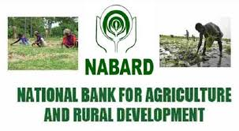
Objectives of NABARD:
- To promote rural development through financial and non-financial interventions in agriculture and rural sectors.
- To provide and regulate credit for the development of agriculture, small-scale industries, cottage, and village industries, and other rural activities.
- To refinance financial institutions such as Regional Rural Banks (RRBs), Cooperative Banks, and other institutions providing rural credit.
- To support rural infrastructure development, such as roads, irrigation, warehousing, etc.
- To promote self-help groups (SHGs), joint liability groups (JLGs), and other community- based rural finance models for inclusive growth.

Benefits of NABARD:
- Agricultural Support: Provides refinance to banks for lending to farmers, promoting agricultural development.

- Rural Infrastructure Development: Funds projects like irrigation, roads, and rural electrification.

- Promoting of Self-Helps Groups(SHGs):Empowers rural women and supports microfinance for self-employment.

- Credit Planning & Monitoring: Prepares credit plans and monitors rural credit flow effectively.

- Sustainable Development: Supports eco-friendly and climate -resilient farming practices.

COVERAGE

- SECTORAL COVERAGE:
- Agriculture: Crop production, irrigation, farm mechanization, horticulture, and allied activities (dairy, poultry, fisheries).
- Rural Development: Infrastructure like rural roads, bridges, drinking water supply, and sanitation.
- Microfinance: Self-Help Groups(SHGs), Joint Liability Groups(JLGs), and other small-scale rural enterprise.
- Non-Farmer Sector: Support to rural industries, crafts, and cottage industries.

- INSTITUTIONAL COVERAGE:
- Cooperative Banks
- Regional Rural Banks(RRBs)
- Commercial Banks(for rural lending)
- State Governments(for infrastructure development)
- NGOs and MFIs (for SHG and microfinance programs)

- GEOGRAPHICAL COVERAGE:
- Pan- India: NABARD operates in all states and union territories, with special focus on.
- Backward and tribal regions
- North Eastern states
- Drought-prone and underdeveloped rural areas.

4.PROGRAMMATIC COVERAGE:
- Refinancing schemes
- RIDF (Rural Infrastructure Development Fund)
- Financial inclusion programs
- Climate-resilient agriculture
- Watershed development projects
- Skill development and capacity building

Bhamashah Yojana (BY)

Bhamashah Yojana is a scheme introduced by the Government of Rajasthan to transfer financial and non- financial benefits of governmental schemes directly to women recipients in a transparent way. The scheme was inaugurated by Chief Minister Vasundhara Raje on 15 August 2014.The scheme is named after the Bhamashah a famous minister, financier and general who helped Maharana Pratap.
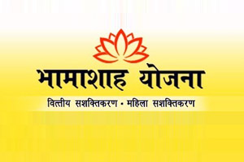

Bhamashah Yojana

Location | Ajmer
State | Rajasthan
Launched | 2008
Website | Bhamashah rajasthan.gov.in

In an attempt to make women more self-sufficient Bhamashah Yojna was launched by C.M. Vasundhara Raje on 15th August 2014. This is the largest scheme aimed at the financial inclusion of women. The Bank of Baroda has also co-joined and branded for this scheme. This scheme has aimed at:
• Providing cash amount of Rs 2000 in the name of woman head of every BPL family of the state in two installments.
• Bank A/c s are also being opened in the name of women heads being opened for about 1.5 crore families.
• Second installment of Rs 1000 would be transferred in the bank account 6 months after the first installment
. • This scheme has also been integrated with the PMJDY so that the benefits of that scheme can also be availed.
• Under this scheme the Bhamashah card holder women would be able to get rations from the PDS shops using Bio- Metrics system.

Women became the head of the family
The Rajasthan government launched Bhamashah Yojana to directly and transparently benefit women empowerment and government schemes. Under the scheme, the bank accounts of the family have been opened in her name by making the woman the head of the family. The government is giving all the government cash benefits to the family directly in this account. Rajasthan is the first state in the country where this has happened.

Arrangement of sending the amount directly to the bank account
At the time of enrollment in Bhamashah, complete information about the family and all its members is added to Bhamashah. All government schemes to which any family member is entitled, their information (eg. pension number, NREGA job card number etc.) is also linked to Bhamashah. The bank account of the beneficiaries is also linked to Bhamashah, so that the benefits of government schemes (pension, NREGA, scholarship, Janani Suraksha etc.) are directly delivered to their bank accounts on the due date.

Objectives
Launched with the objective of financial inclusion of women and their empowerment, the Rajasthan Bhamashah Yojana was initially launched in the year 2008, when around 50 lakh women applied, and only 29 lakh accounts could be opened at the time. The project aims to make women financially independent and provide the benefits of multiple other schemes through the Bhamashah Card Yojana.
The Bhamashah card given under this yojana is linked to a bank account in the name of the woman of the house. The card also provides biometric identification and core banking functions to the women, along with multiple cash benefits which are directly transferred to the bank account.

Features of Bhamashah Yojana

- The government benefits from the Bhamashah Yojana are directly transferred to the beneficiary’s account, which further helps in reducing corruption
- The scheme intends to transfer the benefits offered by the State Government directly to the needy women of the society
- The scheme enabled 1.5 Million women to open their bank accounts and avail the benefits
- The students and physically disabled people who are eligible for the scheme are issued the Bhamashah Card
- Men can also avail the benefits of the Bhamashah card by paying an amount of Rs.20 or Rs.25
- The Bhamashah Card also offers a medical insurance of Rs.30,000 to Rs.3Lakh to the poor and deprived in case of medical emergencies
- The women having the Bhamashah Card will be able to purchase ration from the shops using the biometric system

Eligibility

The following conditions must be met in order to be eligible for the Bhamashah Yojana

- Children must be enrolled in government schools and colleges that are looking for enrollment in academic institutions for the preparation of coaching exams.
- Adults seeking financial help for setting up a business
- Women who are fighting for their identity and trying to establish themselves as a leaders
- Patients seeking help for medical ailments and need financial assistance for operations
How to Apply for Bhamashah Yojana

Offline Application Process
To apply for the scheme offline, the candidates can visit the camp organized for every ward by the state government in all the village panchayat in all the rural and urban areas.

Online Application Process
The eligible candidates can also apply for the Bhamashah Yojana online by providing their Aadhaar number. The candidate will be asked to fill a form, whose information will be used for the generation for the Bhamashah card.
In case the candidate does not have her Aadhaar number, the candidate can get out her Aadhaar card through e-Mitra- Kiosk and then apply for the scheme.

How to Update Details on the Bhamashah Portal

In case of any changes in the Bhamashah card, the candidates can visit the official website and and make the changes on their own. The following information can be updated on the online Bhamashah portal

- Addition of a new member in the family
- Wedding of any member of the family
- Death of a family member
- Change in the residential address
- Changes in relevant information such as Bank Account
However, for Bhamashah online editing, the candidate will have to use her SSO ID

Documents Required to Apply for Bhamashah Card

The following documents should be submitted while applying for the Bhamashah card online-
- A copy of the application
- Caste certificate
- Experience letter (for businesses)
- Birth certificate
- Identity proof (Aadhaar card, Ration card, etc.)

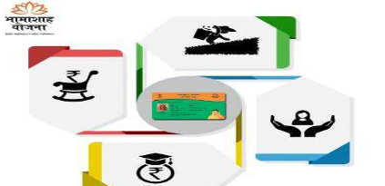

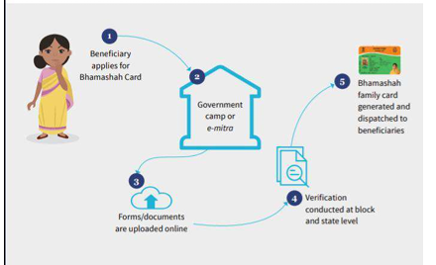

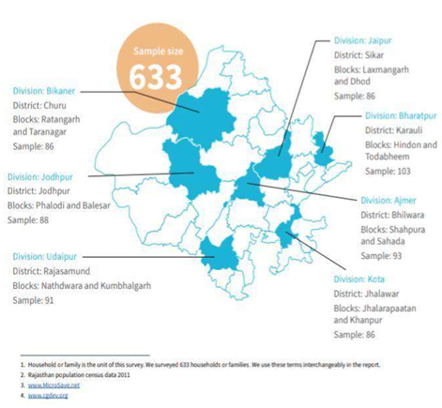

The team also conducted in-depth interactions in the form of focus group discussions (FGDs) and individual interviews. We interacted with Bhamashah beneficiaries, TPDS beneficiaries, NSAP beneficiaries, Bhamashah Swasthya Bima Yojana (BSBY) beneficiaries, fair price shop (FPS) dealers, BSBY empanelled hospitals, and government officials at the block and district levels. The adjacent table illustrates this

District | No.of FDGs/Pls | Beneficiary strength | Stakeholders interviews
Rajsamund | 9 | 43 | 7
Bhilwara | 9 | 36 | 4
Jodhpur | 6 | 36 | 3
Karauli | 7 | 46 | 2

LITERATURE
REVIEW

REVIEW OF LITERATURE

Review of literature is very important to give better understanding and insight necessary to develop a broad conceptual framework in which a particular problem can be examined. It helps in the formation of specific problem and helps acquaint the investigator to what is already known in relation to the problem under review and it also provides a basis for assessing the feasibility of the research.
Review of literature is important to a scholar in order to know what has been established and documented as there are critical summaries of what is already known about a particular topic. Therefore a review of literature helps in relating the present study to the previous ones in the same field.

The review of some of the literature related to the performance of government schemes is shown below:-
There have been many studies on the impact of the Jan Dhan scheme since it was launched. As would be in many government initiated schemes of this magnitude, most of the researchers have identified the achievements as also the failures of the scheme. The report of the committee on financial inclusion in India [2008] defines financial inclusion as the process of ensuring access to financial services and timely and adequate credit where needed by vulnerable groups such as weaker sections and low income group, at an affordable cost.
PMJDY is designed with six pillars so as to provide beneficiaries with:
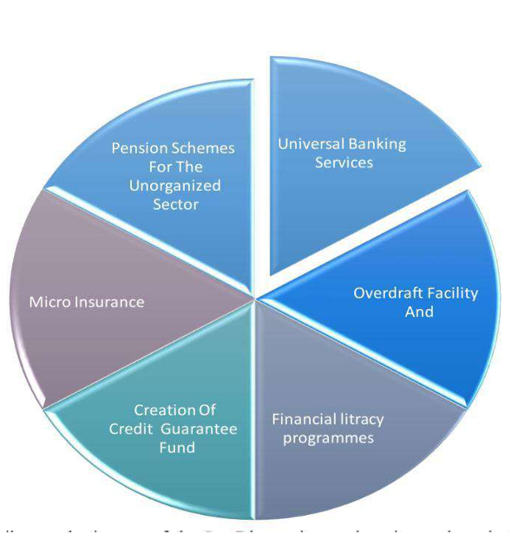
[Kumar and Soni, 2013]
matters connected Regional rural banks play a significant role in the agriculture and rural development of India through their vast network. The success of rural credit in Indian state through RRBs are the key financing establishment at the rural level that shoulders the responsibility of meeting agricultural credit needs. RRBs face the issues of overdue, recovery, non-performing assets and other issues. The resolve these issues the govt. of India promoted Regional Rural Banks[RRBs] through RRBs act of 1976 to bridge the gap in the flow of credit to the rural poor. The paper finished that the RRBs were established to develop the rural economy by providing for the purpose of development of agriculture, trade, commerce, credit and alternative facilities, particularly to small and marginal farmers, agricultural labourers several entrepreneurs.
[Parmar and Ranpura, 2013]
Internet banking in rural areas and its application for many rural consumers in rural areas. The research objectives was to analyze the opportunity of using net banking within the new generation of rural areas that entered on some of the rising trends in rural banking. The research concluded that facility provided by the banks like Term loans, online FD, demand draft facilities etc. are not getting used as much as they were expected to and it was found that the expectations of consumers towards net banking are, it should be time saving and convenient to use, should be user friendly and best in security and therefore the main reason for using net banking facilities would be to have a traditional account within the same bank that would provide excellent net services.

B .Chandra Mohan Patnaik (KIIT University) October 2017
The research paper is an attempt to understand the various initiatives taken by the government for rural banking sector in India. In this regard secondary data is being considered. The main objective of the paper to understand the existing government readiness towards cash less society. Though is a conceptual paper and it will give a direction for undertaking the empirical study on digital transactions and will be added contribution to the existing literature

THE ROLE OF REGIONAL RURAL BANKS FOR RURAL DEVELOPMENT IN INDIA
Mrs. N. Santhi, Dr. T. R. Ganesan (March 2015)
The RRBs were established “with a view to developing the rural economy by providing, for the purpose of development of agriculture, trade, commerce, industry and other productive activities in the rural areas, credit and other facilities, particularly to small and marginal farmers, agricultural laborers’, artisans and small entrepreneurs, and for therewith and incidental thereto” . The multi–agency approach to rural credit was also to sub serve the needs of the input–intensive agricultural strategy (Green Revolution) which had initially focused on `betting on the strong’ but by the midseventies was ready to spread more widely through the Indian countryside. In addition, the potential and the need for diversification of economic activities in the rural areas had begun to be recognized, and this was a sector where the RRBs could play a meaningful role. In this paper we are going to discuss on the role of regional rural banks and their responsibilities towards rural development.
Harish Tigari & M G Gaganadeepa, From Department of Commerce, Davangere University, Shivagangotri, Karnataka, India The rural banking is one of the important roles in rural development of our country, and the village economy is the backbone of the Indian economy. Without the development of the rural economy, the objective of economic planning cannot be achieved. Hence the Regional rural banks (RRBs) are plays a vital role in the rural development for the economy in India. The RRBs were established on October 2, 1975, with the main objective of a provisional credit to rural people who are not economically strong enough, especially the small farmers, artisans, agricultural laborers, and even small entrepreneurs. The present study is a modest attempt to rural credit structure and the role played by RRBs in the development of rural economy. The present research paper is designed in nature and makes use of secondary data. The relevant secondary data have been collected mainly through the articles, journals, books, and websites have been referred. This paper is to examine the rural credit structure in RRBs of Pragathi Krishna Gramin Bank. And this study is focused only on the specific area like loans and advances made by the RRBs for three years period of 2015-16 to the year 2017-18.
Role of Regional Rural Banks (RRBS) and National Bank of Agriculture and Rural Development (NABARD) in Rural Development in India
M. Prabakaran (April - 2014)
Gandhiji said, “Real India lives in villages” and village economy is the backbone of Indian economy. The Government of India is developing rural areas through Five years Plans but it is not achieved target of enhancing rural development. The Regional Rural Banks (RRBs) were established in October 02, 1975 for economic development in the rural India and to provide credit to the rural people by the Government of India. National Bank of Agriculture and Rural Development (NABARD) was set up in July 1982 as apex institution to provide refinance facilities to rural financial institutions. This article explains the role of RRBs and NABARD in developing rural area in India and to analyze the achievement and overall performance of RRBs and NABARD.

RESEARCH STUDY

NEEDS OF THE STUDY

1.To know how rural banking schemes helps to develop the economy and rural areas.

2.To study the schemes launched by rural bank’s in collaboration with government

3.To know the working style of the schemes launched by the launched by the rural banks

Scope of the study
The scope of present study is confined to Regional Rural Banks in India. The study mainly involves the financial performance of Regional Rural Banks in India before and after amalgamation. Similar studies on this line may be conducted for other banks in India and outside India.

OBJECTIVE
OF
STUDY

OBJECTIVES OF THE STUDY

1. To study how it bridging the credit gaps in rural areas.
2. To study how it reduce regional imbalance and increases rural employment generation activities.
3. To know how it is develop the rural area by its schemes and plans.
4. To compare the performance of the schemes launched by rural bank to develop the economy.

HYPOTHESIS

HYPOTHESIS
- Null Hypothesis
H0-There is no significant difference in performance of rural banking scheme launched by RRBs for development in India.

- Alternate Hypothesis
H1-There is significant difference in performance of rural banking scheme launched by RRBs for development in India.

RESEARCH
METHODOLOGY

RESEARCH METHODOLOGY

Research Methodology is a way to systematically solve the research problems. It may understand as a science of study how research is done scientifically.

• Secondary Data: Secondary data is the data that have been already collected by and readily available from other sources. Such data are cheaper and more quickly obtainable than the primary data and also may be available when primary data cannot be obtained at all.
The sources of secondary data are as follows
• Newspapers, News channels, internet-websites, magazines, books-libraries, other projects.

DATA ANALYSIS
AND
INTERPRETATION



Q.1 The first survey was about the age of the customers.
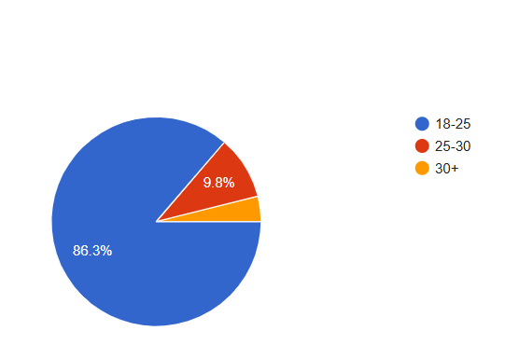
AGE

AGE
This pie chart represents the age distribution of 51 survey respondents, broken down into three age groups:
- 18-25 years old (Blue): 86.3%
This is the majority group, showing that most respondents are in this young adult range.
In numbers: approximately 44 respondents.
- 25-30 years old (Red): 9.8%
A smaller portion of the group is 25+ years old.
In numbers: approximately 5 respondents
- 30+ years old (Orange): 3.9%
This is the smallest age group represented.
In numbers: approximately 2 respondents.

AGE | PERCENTAGE | NO. OF RESPONSE
18-25 | 86.3% | 44
25-30 | 9.8% | 5
30+ | 3.9% | 2
TOTAL | 100 | 51
INTERPRETATION:
- This survey is heavily skewed toward the 18-25 age group, suggesting that the target audience or participant base is predominantly young adults.
- There is a relatively small representation from older age groups, which may reflect either the sampling method or the actual demographic of interest.

Q.2 In the second question, the customers were asked about their gender.
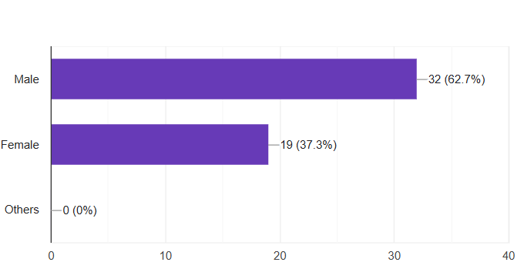

GENDER

This pie chart represents the gender distribution of the same 51 respondents:
- Male : 62.7%
This is the largest gender group in the survey.
In numbers: about 32 people
- Female: 37.3%
Slightly fewer females than males.
In numbers: about 19 people
- Others: 0%
There are no respondents who selected a gender identity other than male or female.

AGE | PERCENTAGE | NO. OF RESPONSES
MALE | 62.7% | 32
FEMALE | 37.3% | 19
OTHERS | 0 | 0
TOTAL | 100 | 51

INTERPRETATION:
- The majority of the respondents or participants are male, making up nearly two-thirds of the total.
- Females account for just over one-third of the total.
- No individuals identified as “Others”.
Q.3 In this question customers were about their occupation.
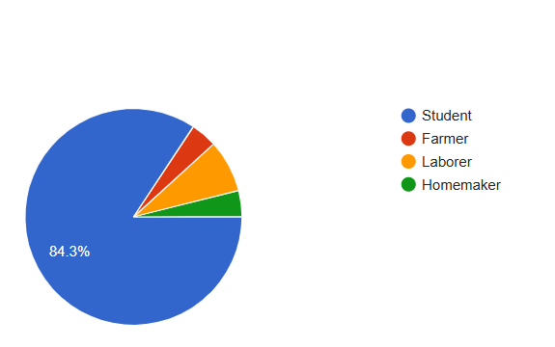

OCCUPATION
This pie chart displays the occupation distribution among the 51 survey respondents:
- Student (Blue): 84.3%
- Farmer (Red): approx. 3.9%
- Laborer (Orange): 7.8%
- Homemaker(Green): approx. 4%

OCCUPATION | PERCENTAGE | NO. OF RESPONSE
STUDENT | 84.3% | 43
FARMER | ~3.9% | 2
LABORER | 7.8% | 4
HOMEMAKER | ~3.9% | 2

INTERPRETATION:
- Dominance of Students
- The student group overwhelmingly represents the population at 84.3%.
- This indicates that the data was likely collected in a setting such as a school, university, or a youth-focused community.
- The focus of activities, services, or interventions here should be tailored towards education, youth engagement, and student welfare.

- Minor Representation of Other Occupations
- Laborers (7.8%), homemakers, and farmers make up less than 16% combined.
- This suggests a limited adult working population or low economic activity in sectors like farming or domestic labor in this group.
- Could also indicate urban or semi-urban demographics, where educational institutions dominate over agricultural or domestic work.

Q.4 Do you have a bank account?

BANK ACCOUNT
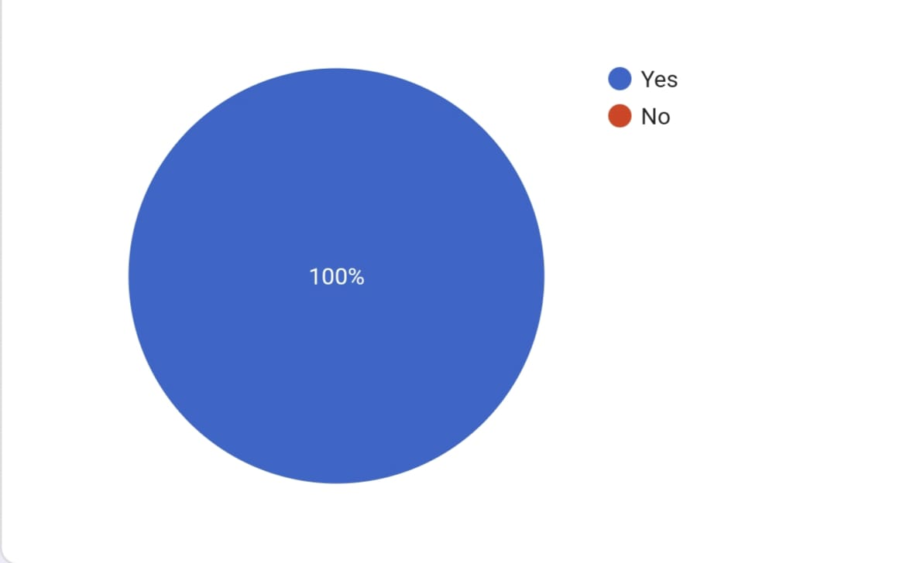

This pie chart shows the number of customers having bank account:
- Yes (Blue) – 100%
- No (Orange) – 0%

Q.5 Monthly income of the customers?

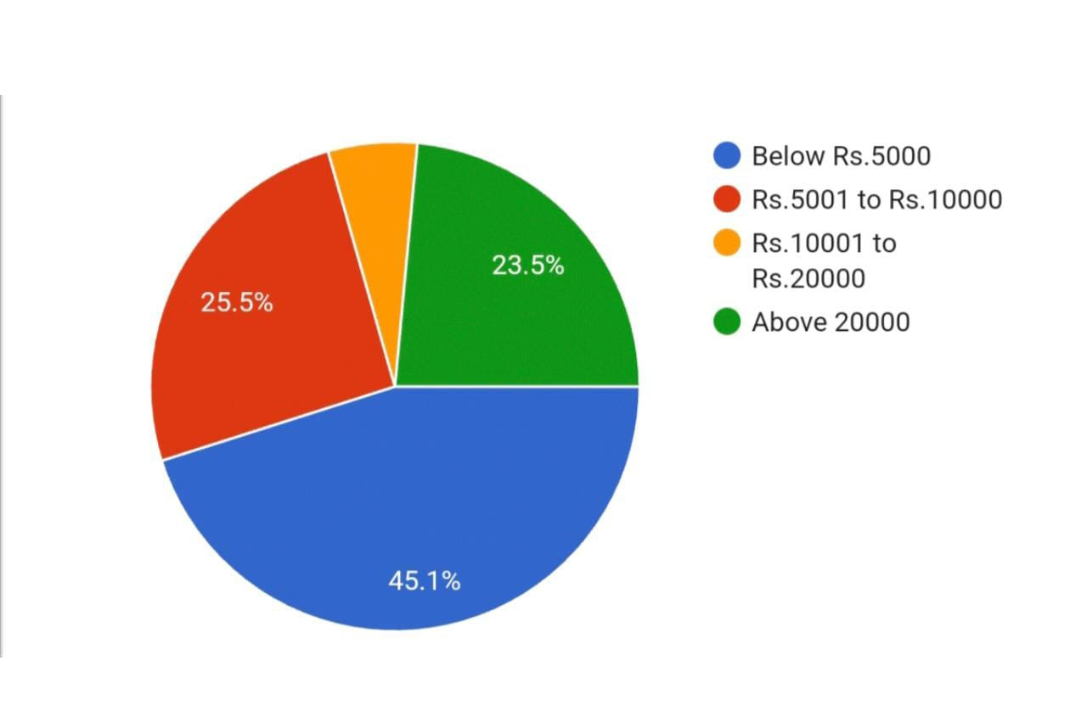

INCOME
This pie chart visually represents the distribution of people based on their income or expenditure in rupees. Below is the breakdown of the data analysis:
- Below Rs.5000(Blue): 45.1%
- This is the largest segment, indicating that nearly half of the people fall into the lowest income or spending bracket.
- Rs.5001 to Rs.10000(Red): 25.5%
- A significant portion, about one-fourth, falls in this lower-middle category.
- Rs.10001 to Rs.20000(Orange): 5.9%
- This is the smallest segment, indicating very few individuals are in this range.
- Above Rs.20000(Green): 23.5%

INCOME | PERCENTAGE
Below Rs.5000 | 45.1%
Rs.5001 to Rs.10000 | 25.5%
Rs.10001 to Rs.20000 | 5.9%
Above Rs.20000 | 23.5%
Total | 100%

Interpretation:
- This chart indicates a skewed income distribution where the majority of people earn on the lower end of the scale.
- The income gap appears to be significant, with very few in the middle-income bracket (Rs.10001–Rs.20000).
- Policies or initiatives aiming to improve income equity or lift incomes of the lowest brackets may be needed.
- The presence of a reasonably large group (23.5%) earning above Rs.20000 could be potential contributors to tax revenue or economic growth.

Q.6 Which bank do you use?

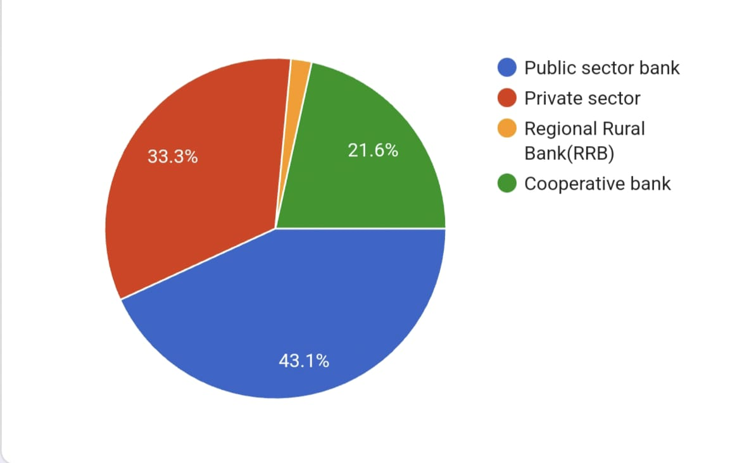

BANK NAME

The pie chart represents the distribution of banks in different sectors. Here's the breakdown of the data analysis and interpretation:
Categories and Their Proportions:
- Public Sector Banks – 43.1%
- Private Sector Banks – 33.3%
- Cooperative Banks – 21.6%
- Regional Rural Banks (RRBs) – Very small (approximately 2%)

TYPE OF BANK | PERCENTAGE
PUBLIC SECTOR BANK | 43.1%
PRIVATE SECTOR BANK
COOPERATIVE BANK
REGIONAL RURAL BANK(RRBs)
TOTAL

CONCLUSION

Swaranjayanti Gram Swarojgar Yojana [SGSY]

In view of the general conclusion that the IRDP was not very effective as a poverty alleviation measure, the Swarnajayanti Gram Swarojgar Yojna (SGSY) was launched in April 1999 by revamping the erstwhile IRDP, Development of Women and Children in Rural Area (DWCRA), Training of Rural Youth for Self Employment (TRYSEM), Supply of Improved Toolkits to Rural Artisans (SITRA), Ganga Kalyan Yojana (GKY) and Million Wells Scheme (MWS). The SGSY was devised keeping in view the positive aspects and deficiencies of the earlier programmes. The SGSY has a definite objective of improving the family incomes of the rural poor and, at the same time, providing for a flexibility of design at the grassroots level to suit the local needs and resources. Golaghat district has achieved a commendable level of success in formation of SHGs in rural areas. It must be admitted that SGSY is a real programme for alleviation of poverty and unemployment in the rural areas. Most of the SHG members are from rural areas but micro-financing schemes have achieved wonders in improving the economic conditions of the rural poor living in inaccessible villages and protecting them from the clutches of the village money lenders. Though SGSY helps in poverty, some factors such as lack of basic facilities, lack of awareness, unnecessary delay of loan sanctioning and improper utilization of funds etc. hinder the beneficiaries. To overcome those constrains awareness and training among the beneficiaries, regular monitoring, minimization of the interest rate and motivation is utmost need to achieve the goal of such schemes

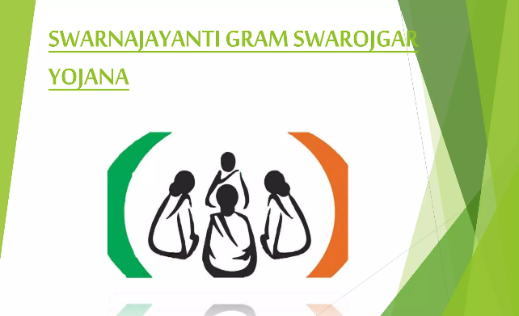

Pradhan mantri rojgar yojna
Pradhan Mantri Rojgar Yojana (PMRY) is the Government initiative that aims to provide selfemployment opportunities to educated youth and women. This scheme has been in effect for the benefit of the eligible applicants since the year 1993. The Government provides financial assistance as well as training for setting up of self-employment opportunities as implementation of the schemes with the banks As a means to promote self-reliance and generate employment, the Government of India has launched multiple schemes and programmes. Pradhan Mantri Rozgar Yojana is one of such schemes formulated to provide monetary assistance to the youth of India and the organised sector in general.To become a beneficiary of the PMRY, find out more about this scheme and its offerings
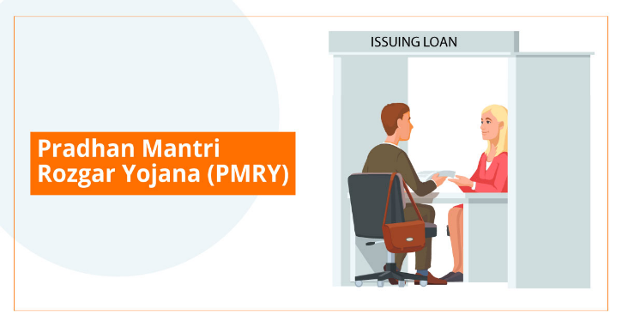

Pradhan Mantri Jan-Dhan Yojana
"Pradhan Mantri Jan-Dhan Yojana” (PMJDY) (Prime Minister’s People Money) is National Mission for Financial Inclusion to ensure access to financial services, namely, Banking/ Savings & Deposit Accounts, Remittance, Credit, Insurance, Pension in an affordable manner. PMJDY focuses on coverage of households as against the earlier plan which focused on coverage of villages. It focuses on coverage of rural as well as urban areas. Earlier plan targeted only villages above 2000 population while under PMJDY whole country is to be covered by extending banking facilities in each Sub-Service area consisting of 1000 – 1500 households such that facility is available to all within a reasonable distance, say about 5 Km. In a short period of time, the scheme has achieved more numbers in terms of account opening well before the target date of 31st January, 2015. The most important challenge is to sustain this performance over a period of time

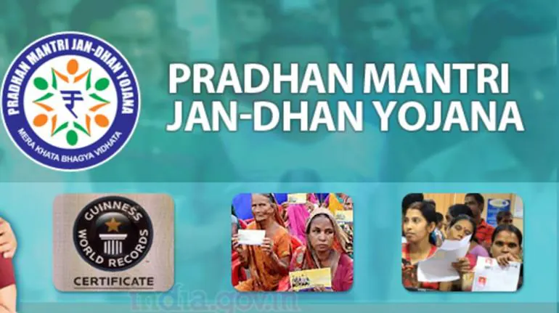

Bhamashah Yojana [BY]
With the objectives of financial inclusion and to empower the women of the State, Bhamashah Scheme was launched, wherein, around 50 lakh ladies were enrolled and 29 lakh accounts were opened. Bhamashah Scheme, an end-to-end service delivery platform to transfer cash and non-cash benefits to the targeted beneficiaries in a transparent manner, was relaunched in the year 2014 with broader objectives. The Scheme is a family-based programme of financial inclusion, where each family is issued a ‘Bhamashah Card’. The Card is linked to a bank account that is in the name of lady of the house who is the head of the family. The card leverages bio-metric identification and core banking. Multiple cash benefits would be accessed through the Bhamashah Card and will be directly transferred to bank accounts of the beneficiaries. Non-cash benefits would be given directly to entitled beneficiaries. It is one of its kind scheme where all benefits—cash and non-cash, e.g. services of Public Distribution System (PDS), Education Scholarships, payments under MNREGA and Social Security Pensions, benefit of other Schemes like Distribution of Scooties to Students, Indira Awas Yojana, CM BPL House, Janani Surakha Yojana, Unemployment Allowance, Skill Training, other individual beneficiary schemes and many other services will be routed through Bhamashah Scheme

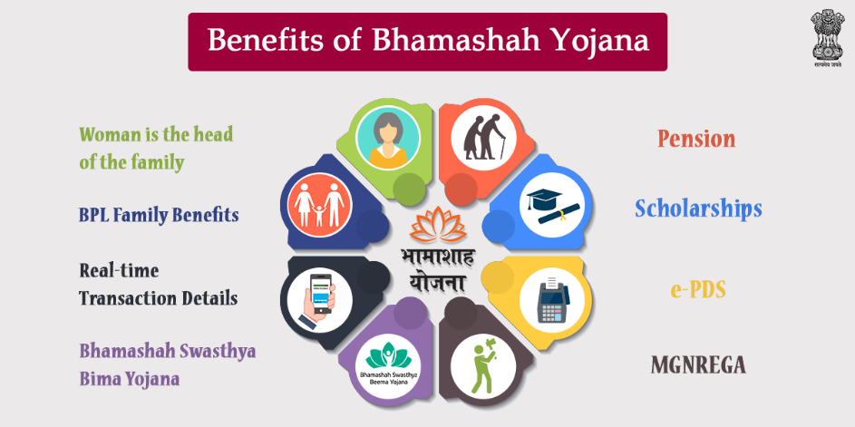

Kisan Credit Card
The Kisan Credit Card (KCC) is a government-backed scheme launched in India to provide short-term credit support to farmers for their agricultural needs. It offers farmers financial assistance to meet their crop production expenses, such as purchasing seeds, fertilizers, and other inputs, as well as for post-harvest expenses. The card is designed to provide easy accessto credit for farmers, with minimal paperwork and a quick disbursement process



National Bank for Agriculture and Rural Development(NABARD)
NABARD plays a pivotal role in the growth and development of rural India by promoting sustainable agriculture, rural infrastructure, and financial inclusion. As a dedicated apex development bank, it bridges the gap between rural financial needs and institutional support, empowering farmers, self-help groups, and rural enterprises. Through innovative policies, credit facilitation, and capacity-building initiatives, NABARD continues to strengthen the rural economy, ensuring inclusive and balanced development across the country.

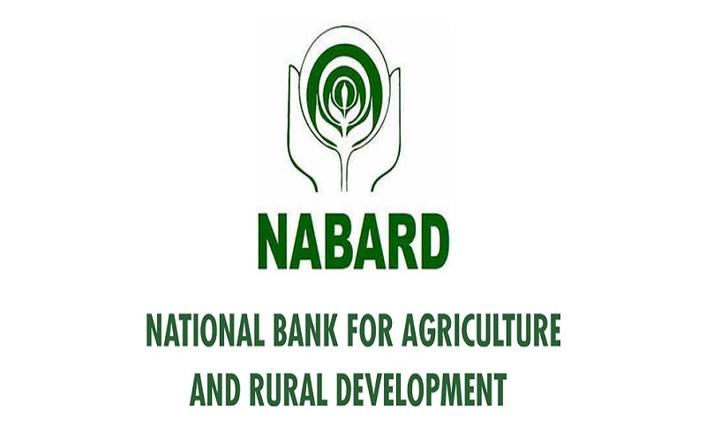

SUGGESTION

The section tries to present certain problems and suggestion. The problems and suggestion emerges from observation made on the performance position of mutual funds taken for the study.
Swarnajayanti gram Swarozgar Yojana
• I would like to suggest that the government should provide them market facilities through the public distribution system. Government should also organized handicraft fare, weekly market etc. where these beneficiaries can sell their product and get profit out of it.
• Here I suggested that the central government should give some authorities for the approval of the projects to the state level committee which will make the scheme easier for individuals and self-help groups.
• As already written above that most of the individuals and self-help groups have complaint about the corruption at the different level of committee that is from village Panchayat to central level committee including banks. Today corruption is everywhere i.e. from central government to gram Panchayat. Corruption is a major problem that India is facing today, it is running the whole democratic system of India. If this corruption is not checked immediately, the whole democratic system in the country will collapse soon. The moral values of the society have gone down. It is evident in almost all sphere of life in India. Thus, government should take immediate step to check the corruption

Pradhan Mantri Rozgar Yojana
• In this scheme I suggest that, the Government of India may consider that eligibility age limit may be increased from 18 to 35 to 18 to 40 under PMRY scheme.
• Bankers should change their attitude and have to develop an entrepreneurial atmosphere in order to promote the entrepreneurial culture among educated unemployed youth rather than working for achieving target only.
• Here I suggest that the Training is imparted by recognized institutions such as university, colleges, and non-governmental organizations with the help of potential resource persons. It has been considered an important input for the growth and development of individual beneficiaries, leading to inculcate necessary soft skills to the aspiring entrepreneur

Pradhan Mantri Jan Dhan Yojana
• People may face problem due to ATM in rural areas as there is low network of ATM so people are not well know how to use ATM.
• Many areas like parts of North East, Himachal Pradesh, Uttarakhand, Jammu & Kashmir etc. are facing challenges of infrastructure and telecom connectivity. In these areas all household may not be fully covered under campaign
• This is the one of the major problem as most of the people are aware of it but still they are not turning into bank account user may be because they are not still understand the proper channel of opening bank account under Pradhan Mantri Jan Dhan Yojna.
Bhamashah Yojana
• I think as early as while doing research the team had realized that no single survey will ever be enough to understand the information related to schemes.
• City or villages wise surveys covering the entire state.
Kisan Credit Card
- Know Your Eligibility
- All farmers (individuals, joint borrowers, tenant farmers, oral lessees, sharecroppers) involved in crop production or allied activities like dairy, poultry, fishery, etc. are eligible.

- Keep Required Documents Ready
- Identity proof (Aadhaar, PAN, Voter ID)
- Land ownership proof or lease papers
- Passport-sized photographs
- Bank account details

- Choose a Bank That’s Farmer-Friendly
- Approach public sector banks (like SBI), cooperative banks, or regional rural banks.
- Some private banks also offer KCCs with added services—check terms and compare.

- Request a Reasonable Credit Limit
- The credit limit depends on land holding, cropping pattern, scale of finance, etc.
- Don’t ask for more than what you need—it might impact your future borrowing capacity or lead to higher interest payments.

- Ensure Timely Repayment to Get Interest Subsidy
- Repaying loans on time (within the due date, typically up to 12 months) gets you an interest subsidy of up to 3%, reducing the effective interest rate.

- Use It for the Right Purpose
- The card is meant for agriculture-related expenses like seeds, fertilizers, equipment, and other working capital needs.

National Bank for Agriculture and Rural Development.

- Explore NABARD Refinance Schemes
- NABARD doesn’t give loans directly to individuals—it refinances banks that lend to farmers.

- You can benefit indirectly through:
- Crop loan
- Term loans for irrigation, farm mechanization, horticulture, etc.
- Dairy and animal husbandry projects

- Take Advantage of Subsidy-Linked Scheme
- NABARD implements various subsidy schemes under government programs:
- Dairy Entrepreneurship Development Scheme (DEDS)
- Integrated Development of Small Ruminants
- Solar pump subsidy
- Agri-clinics and Agri-business Centres (ACABC)

- Check Out the Rural Infrastructure Development Fund (RIDF)
- If you’re connected to a Panchayat or local body, you can suggest infrastructure projects that NABARD might support, like:
- Irrigation facilities
- Rural roads
- Warehousing and cold storage

- Apply for Agri-Business Incubation Support
- NABARD supports agri-startups and incubators through its NABARD Agribusiness Incubation Centres (ABICs).

- Use the SHG Bank Linkage Programme
- NABARD has been a pioneer in promoting Self-Help Groups (SHGs).
- SHGs can avail microcredit from banks and get capacity-building support.

- Leverage Financial Literacy & Skill Development Programs
- NABARD supports training programs in rural areas (e.g., tailoring, handicrafts, goat farming).
- NGOs and rural development institutions can get funding to conduct these trainings.

BIBLOGRAPHY
Web Sites:
www.shodhganga.com
www.researchgate.net
www.nabard.org
www.microfinancegateway.org
Kumar, A.K. & Soni, A.K, [2013].A study on current status of Regional Rural Banks in India.
Parmar, B.J., & Ranpura, D.B.[2013].A study on use of internet banking among rural consumers. Asian Journal of Management.

REFERENCES:

- Aagarwal H.C. (1991), Practice and Law of Banking, Swan Publication,Agra

- Bedi R.D.(1983) , Theory History and practice of co-operation, Loyal, Book Depot, Merrut.

- Jessica A. Los Banos (2007), rural banks resource allocation efficiency and regional economic performance, Philippine management review Vol: 14, Pp. 115-126.

- K. Sudhalakshmi and K.M. Chinnadorai (2014) ,Green growth strategy Indian co-operative banks, International journal of research in management, economics and commerce, Vol: 4, Issue:3.

- Sandeep Kaur, (2012),Growth of commercial banks in India,
International journal of business and management tomorrow, Vol: 2.

